Abstract

In 2010, the Philippines adopted the Automated Election System (AES) to comply with the Republic Act No. 9369 which stated that the Commission on Elections (COMELEC) should use an AES that establishes transparency and credibility. However, during the 2016 Presidential Elections, the possibility of electoral fraud continued to persist through the existence of a ‘secret server’ and the controversy behind the hashing algorithm used in system. The study aims to propose a technical solution that would eliminate the possibility of unofficial servers by implementing a public key infrastructure and using the Diffie-Hellman algorithm as security measures for the transmission of votes on the server-level. This will allow the Voting Counting Machine (VCM) to first verify the authenticity of the server before sending the election results which addressed the one of the major problems found in the current system. Moreover, the application of the security technique would lead to a more secure and reliable automated election system thus reestablishing the election results’ credibility.

INTRODUCTION

Background of the Problem

After years of having a manual voting system, the Philippines has finally adopted an Automated Election System (AES) in 2010. This was mandated by Republic Act No. 9369 which is the Amended Elections Automated Law. The law stated that there would be paper-based election system defined as “a type of automated election system that uses paper ballots, records, and counts votes, tabulates, consolidates, canvasses, and transmits electronically the results of the vote counts.” (Angkaya, 2011).

The Automated Election Systems in the Philippines follows a sequence of process. Focusing on the transmission module of the system, the process starts when the polling precincts closes on the election day. The PCOS machines transmit the vote counts or election returns (ERs) to the corresponding servers and canvassing centers. From the PCOS machines, the ERs are transmitted to the central server, to a transparency server, and to the consolidation and canvassing servers.

During the transmission of ERs, electoral fraud is inevitable. There are many issues concerning the effectiveness and efficiency of the machine and servers during the elections. For instance, the camp of Senator Ferdinand Marcos Jr., who ran for the position of vice president, expressed his concerns about the alleged “Secret Servers”. Smartmatic’s Marlon Garcia, the head of the technical support team, admitted that aside from the three servers that were authorized by the COMELEC, there was also a “meet-me room” where several servers were housed. It has also been further disclosed that the secret servers were intentionally not mentioned by the COMELEC and Smartmatic to the public making it more suspicious. The purpose of the said “secret server” or the “queue server” is to first receive all the transmitted votes before distributing it to the three official servers declared by the COMELEC. However, the normal process that should be done for the ER transmission as mandated by the law is to simply transmit the votes directly to the said servers. These servers are the Municipal Board of Canvassing Server, the Central Server, and the Transparency Server. Now, the purpose of having three separate servers is to make it harder for malicious individuals to penetrate and manipulate the election returns. But with the existence of the said “secret server”, the integrity of the system is now uncertain. Moreover, another problem being pointed out was that the “secret server” never undergone the initial source code review which is essential in every machine that would be used during the elections. Additionally, there were no watchers assigned in the said server putting the integrity of the May 2016 elections under a cloud of doubt.

Amidst the controversy of the existence of “Secret Servers”, there has also been a dispute on the altering of the source code resulting to a regeneration of hash codes. From a leaked screenshot, it has been evident that Smartmatic and COMELEC use the MD5 hash code algorithm and at the same time show that the hash codes mismatched after the alteration was made. However, IT experts claim that the use of MD5 is questionable when it comes to its reliability in securing the data. MD5 is an open source and it has been used to verify the file’s integrity.

Statement of the Problem

How can the Philippine Automated Election System eliminate the possibility of unofficial servers to secure the transmission of election returns on the server-level?

Objectives

General

* To know the issues present in the transmission of the votes; and,
* To propose a system that would prevent electoral fraud in the transmission of votes in the automated election system

Specific

* To provide a technical solution that would verify the authenticity of the servers and VCMs using a public key infrastructure and Diffie-Hellman algorithm as security mechanisms for the AES

Significance of the Study

The findings of this research will benefit the following key players:

To the Filipino Citizens

This study will benefit the Filipino citizens for ensuring the security of the casted votes. Also, it would prevent malicious individuals from manipulating the votes. Although the nature of automation easily provokes fear to ignorance of using technology, this study will educate some of those users that still lack computer literacy foundation. Indeed, education can bridge the existing gaps and even remove the unnecessary fear from automation. This will leave the citizens better equipped for the future of the Philippine automated election system.

To the COMELEC

This research would significantly contribute to the goal of the COMELEC to conduct a fair and transparent election. Considering the impact of the elections in the overall condition and future of the Philippines, it is important to make sure that the voters’ choice reflect the outcome of the election. To do that, the system should be able to prevent and mitigate electoral fraud while ensuring that the voters have casted their votes in a way that is convenient and voter-friendly. This study will aim **at** determine the most appropriate methods to achieve the kind of system that does not manipulate the vote of the people in any way through data gathering and research. In this manner, the people will be knowledgeable about how the system works and be informed and wise voters themselves.

To the Future Researchers

As the Philippines adjusts to this kind of voting system, more and more developers would also contribute to the AES aspect of software development. In that case, the system that would be created can serve as a guide and inspiration for other developers who would want to pursue the prospect of automated election system too.

Scope and Limitation

The scope of the study would only include the issues and possible solutions for the security of the transmission of election returns on the server-level of the automated election system in the Philippines. Solutions for the issues present prior and subsequent to the transmission of the election returns will not be provided in this study. The focus of the research will only be upon the elimination of transmission of election returns to unofficial servers as well as the validity of election returns being received. Further study on the other parts of the automated election system will no longer be covered.

REVIEW OF RELATED LITERATURE

Related Literature

**Automated Election System**

On election day, as the polls close, the BEI immediately administers the transmission of the votes or election returns via the PCOS machines equipped with modems to the servers and canvassing centers The Electronic Results Transmission Service is responsible for the transmission of the votes. The primary channel used is through the public telecommunications networks and if that fails, transmission will then be run through the satellite. Furthermore, a software called the Real-time Election Information System, reads the data and canvasses the votes. After the transmission from the PCOS machine, the ERs are transmitted to the central server, to a transparency server, and to the municipal board of canvassers (MBOC). Those three are the official servers declared by the administrators or officials of the elections. Moreover, the MBOC transmits it to the provincial board of canvassers (PBOC) where they consolidate and later transmit the results to the national board of canvassers (NBOC). Additionally, both the MBOC and PBOC send ERs to the central servers.

There was a special case in ARMM wherein they established the regional board of canvassers (RBOC). The results for ARMM governor, vice governor, and assembly men are tallied before being transmitted to the central server.

During the 2016 elections, the congress had their own server wherein the members of the senate and house of representatives can monitor the canvassing of the votes and to officially proclaim the winner for the national level. (Retrieved on August 27, 2016 / <http://www.rappler.com/newsbreak/iq/91663-philippine-automated-election-sytem-explained>).

**Issues in the system**

During the 2016 elections, Bong Bong Marcos’ camp believes that there exists a “Fourth Server” or also known as the “Queue Server”. It has been revealed that the Comelec and Smartmatic have been keeping it from the public. Instead of letting the ERs be directly transmitted to the three official servers, namely the CCS, Central Server, and the Transparency server, the results were first being processed and consolidated in the “Queue Server”. Another problem with the secret server is that the source code being used was never reviewed despite being a requirement in the law. Moreover, there were no poll watchers assigned for these servers making it questionable to both the public and the administrators. According to Rodriguez, a representative of Marcos’ camp, the integrity of the 2016 May elections has been questioned because of the unexpected situation made by the COMELEC and Smartmatic. The ERs that were presented to the public did not come directly from the transparency server. Alternatively, the results were first transmitted to a “Queue Server” where they were “consolidated and processed” and the “Queue Server” sends the data to the transparency servers which is against the law. (Retrieved on August 10, 2016/ <http://www.manilatimes.net/smartmatic-admits-using-unofficial-servers/275442/>)

Officially, there are three servers namely, the transparency server, the central server, and the canvassing center servers. When a voter fills out a ballot, it would be fed into the Vote Counting Machine (VCM). The data entering into the machine would not be sent to its corresponding servers until the end of the voting period. The votes are then transmitted to the three servers that are independent from each other. This is to secure the data and to make cheating difficult for attackers. It is impossible to hack all 3 servers that are not connected to each other because the results would always be different. Changing the data in one server is not going to change or update the other two and to rigged the election results all three servers would have to be breached to make those results valid. (Retrieved on August 10, 2016/ <https://kami.com.ph/9430-6-things-filipinos-know-vote-counting-machine-issue.html>).

**System Vulnerabilities**

The MD5 Security Algorithm

In 1992, MD5 (Mekle-Damgard 5) security algorithm was developed to address the problem of the MD4 algorithm. It is known to be an open source and is widely use to ensure the data’s integrity. However, after 4 years of its development, weaknesses with the said algorithm were discovered upon the researches done by a computer scientist based in the University of California. Moreover, in 2007, Lenstra and Stevens, both are computer scientists, further showed that the MD5 is not a reliable algorithm to use because they found out that the hash function is vulnerable of collisions. This means that two different files with different functions may produce identical MD5 hash values which shows that MD5 is not enough to secure the data’s integrity. The Carnegie Mellon University Software Engineering Institute also rejected the MD5 security algorithm after discovering that attackers of the system can generate data that illegitimately appear to be authentic. They stated that the MD5 algorithm should be considered cryptographically broken or unsuitable for further use. If the MD5 failed to meet its purpose, there are other hashing algorithms that can be used to verify the integrity of the files. (Retrieved on August 28, 2016/ <http://www.thinkingpinoy.net/2016/05/bbm-vs-leni-comelec-smartmatic-obsolete-MD5-technology.html>).

On the other hand, Microsoft, a well-known software company, took a small step to increase the security of enterprises by following industry standards that weaker/shorter key lengths were no longer viable for production use. Microsoft announced a security advisory that will block the MD5 hash algorithm. This hashing algorithm is quite long in the tooth and has not been a recommended hash for many years. (Retrieved on August 28, 2016 / <https://pkisolutions.com/goodbye-md5-sooner-than-you-think/>).

Several researchers at the Chaos Communication Congress in Berlin showed the weakness of MD5 in which the same hash value was generated with two different files. Although it has been known that it is possible to generate the same hash value, this has been the first time to be demonstrated in just a matter of three days using 200 Sony Playstation3 consoles. It is known that it would take a few years for it to happen. Most industry companies have already been discouraging the use of MD5 for some time and promoting the use of stronger hashing algorithms such as SHA1. These new exploits will certainly push developers away from MD5 to avoid further complications. (Retrieved on August 28, 2016 / <http://www.maravis.com/is-it-goodbye-md5/>).

Hash Codes

The source code is a sequence of programming code typed by a computer programmer and is readable to humans. It is then converted into a machine readable form known as a compiled or executable program and is dependent to the source code. This is the reason why there should be a source-code review before being converted into an executable program. Each source code is handled by the MD5 command that generates hash codes which serves as the digital fingerprint. The generated hash code is the assurance that whatever has been tested would be the same for the machines used in the elections. If someone changes even a single line of code, the resulting hash code would be different. (Retrieved on August 28, 2016 / <http://www.thinkingpinoy.net/2016/05/bbm-bongbong-marcos-leni-robredo-comelec-hash-code-cheating-math.html>).

PKI

Public Key Infrastructure has been around for quite a while. However, the method of using a public key and a private key in relation to an encrypted message exchange seems straightforward enough, and yet, it has taken a long time for PKIs to become commonplace. The PKI is known for its complexity in managing certificates and keys which needs to be considered. Implementing and managing a PKI is consequently a task not to be taken lightly, and one which will require both commitment and an appropriate level of expertise. Despite its reliability in securing data, many organizations are still hesitant to implement it because they believe that certificate and keys could somehow take care of themselves because of the growing change about IT securities. As with many technological concepts, the key to wider acceptance lies with ease of implementation and usage. Historically, this has been a downfall for PKI which has often been perceived as over complicated and resource-heavy from a management perspective. Wider adoption increases familiarity of course, but even so, many might struggle with the detail of managing an organization wide PKI. Wider scale implementations require very careful consideration. August 28, 2016 / <https://www.reconnaissance.net/secure-document-news/issues/april-2016/>).

Related Study

Experimental Design of Worldwide Internet Voting System using PKI

In this study, the researchers designed an Internet voting system applicable for worldwide voting which was based on Ohkubo et al.’s scheme combined with Public Key Infrastructure. In the system, voter’s privacy was guaranteed by using blind signature and mix-net, and robustness which was provided through the threshold encryption scheme. A way of typical implementation for internet voting system was proposed by employing Java technology. PKI allowed worldwide key distribution and “one certificate/one vote” policy. Therefore, anyone can participate if the certificate was given by Certificate Authority (CA). By the joint work between Korean and Japanese teams of this study, the implementation aimed to select MVPs in 2002 FIFA World Cup Korean-Japan in easy and friendly manner for any internet user to participate. (Retrieved on August 27, 2016 / <http://citeseerx.ist.psu.edu/viewdoc/download;jsessionid=311B92E00249A90FA1A9557F7E3ABA46?doi=10.1.1.6.1111&rep=rep1&type=pdf>). In this study, it was showed it is possible to incorporate a PKI in a voting system. Not only it was possible, it was also recommended for security purposes of the system.

Hybrid Encryption/Decryption Technique Using New Public Key and Symmetric Key Algorithm

The research study that has been conducted by the college students of the National Chengchi University proposes a new security system that could address the concerns regarding a transmitted data’s integrity, confidentiality, and authenticity. They designed a hybrid cryptography that requires the use of a public-key cryptosystem for convenience and a symmetric-key cryptosystem for efficiency. Hybrid encryption is a mode of encryption that combines two or more encryption systems. It integrates a combination of asymmetric and symmetric encryption to benefit from the strengths of each form of data encryption. These strengths are respectively defined as speed and security. The researchers claim that the combination of encryption methods has various advantages. One is that a connection channel is established between two users’ sets of equipment. Users then have the ability to communicate through hybrid encryption. Asymmetric encryption can slow down the encryption process, but with the simultaneous use of symmetric encryption, both forms of encryption are enhanced. The result is the added security of the transmittal process along with overall improved system performance. (Retrieved on November 10, 2016 / http://gebrc.nccu.edu.tw/misr/pdf/volume/1902/1902-01-fullpaper.pdf). In the research study, it was indicated that the combination of both types of security algorithm can enhance the protection of data is transferred which could be used in the Philippine Automated Election System. It addresses the main problem of the current system which is to maintain the data’s integrity and to avoid electoral fraud caused by malicious attackers.

Diffie-Hellman and Its Application in Security Protocols

With the wide use of the Internet, people around the world can communicate with each other using their computers or other mobile devices. Communication has been made easy through the ongoing advances in technology. However, it has been evident that there are complications in trying to build an effective and secured line of communication through the internet since anyone can easily access it and an outside user that is not part of a particular communication line can simply steal the information. This being a security threat, information security therefore plays an important part in internet transactions. Cryptography is an indispensable tool for protecting information in computer systems. The Diffie-Hellman key exchange is one of the most well-known security algorithms. The algorithm itself does not encrypt data, but instead it generates a secret key common to both the sender and the recipient. A series of mathematical process is done in order to come up with the common and achieve the said algorithm. However, the Diffie-Hellman algorithm is not fool proof because of its known weakness which is the main-in-the-middle vulnerability. In this attack, an unwelcomed individual or also known as “the eavesdropper” would try to interrupt the key generation process. However, the study explained that despite the issue regarding the Diffie-Hellman protocol has been applied to many security protocols including the Security Sockets Layer(SSL), secure shell (SSH), and IP Sec because with proper authentication mechanisms, proper prime generation, and true randomness in picking variables, the protocol can be a powerful component in many a security measure. (Retrieved on November 10, 2016 /http://www.ijesit.com/Volume%201/Issue%202/IJESIT201211_12.pdf). In the current study, the researchers considered using the Diffie-Hellman algorithm and the public key infrastructure. This is a combination of both types of security system which is the asymmetric and symmetric. This is to address the issues or weaknesses of both cryptographic system and to further ensure the proposed system’s capability of securing the data transfer from one entity to the other.

A Study on the Hybrid Encryption Technology in the Security Transmission of Electronic Documents

Through the years it has been apparent that the transmission of data electronically created a new environment for users who seek convenience and efficiency. With its development however, it is inevitable that complications may arise. For instance, there is a possibility that an electronic document intended to be seen by only selected individuals would be tampered, counterfeited, and repudiated. In order to solve those problems, there should be an improvement in the security mechanisms used in today’s systems. A research by Hu Xinli and Ma Lianjie focuses on the development of a hybrid encryption technology which includes an encryption technology, digital digest, digital authentication and digital signature. Each module of the hybrid system has the ability to prevent malicious attacks that could affect the data or documents being transmitted. The encryption technology is to ensure the confidentiality of information while the Digital Digest module ensures the integrity of information. On the other hand, digital authentication and digital signature technology can be certified to protect the Authentication identity, non-repudiation and non-counterfeit. By using the hybrid encryption technology designed, the security of electronic documents will be greatly improved. (Retrieved on November 10, 2016/ https://www.computer.org/csdl/proceedings/isme/2010/4132/01/4132a060.pdf).

THEORETICAL BACKGROUND

Cryptography

Cryptography is considered to be the most effective technique used in securing data in the modern times. It is the method of storing and transmitting data only to those who are intended to access it and is legible.

Plaintext

Encryption

Ciphertext

Decryption

Plaintext

*Figure 1. Cryptography process*

A Cryptosystem is the implementation of a cryptographic process by means of hardware or software. It provides confidentiality needed for ensuring that the data can only be accessed by those who are authorized. Also, cryptosystem has the ability to check whether the data has been altered in order to maintain integrity. Moreover, it has the capability of authenticating the identity being claimed. It also checks the privileges of users in a file which is known as authorization. Lastly, the cryptosystem also acts to make sure that an individual cannot refute the authenticity of their signature on a document or the sending of a message that they originated. All of the said functions of the cryptosystem help in creating a protected environment for users in sending all types of data through different platforms. (Retrieved on December 5, 2016/http://citeseerx.ist.psu.edu/viewdoc/download?doi=10.1.1.259.2641&rep=rep1&type=pdf).

Each algorithm in data encryption or cryptography has their own approaches. Moreover, they are classified as either Symmetric or Asymmetric. Both types of cryptography have their strengths and weaknesses but if used well, then it could easily be implemented in order to attain the desired security mechanism.

Symmetric Encryption

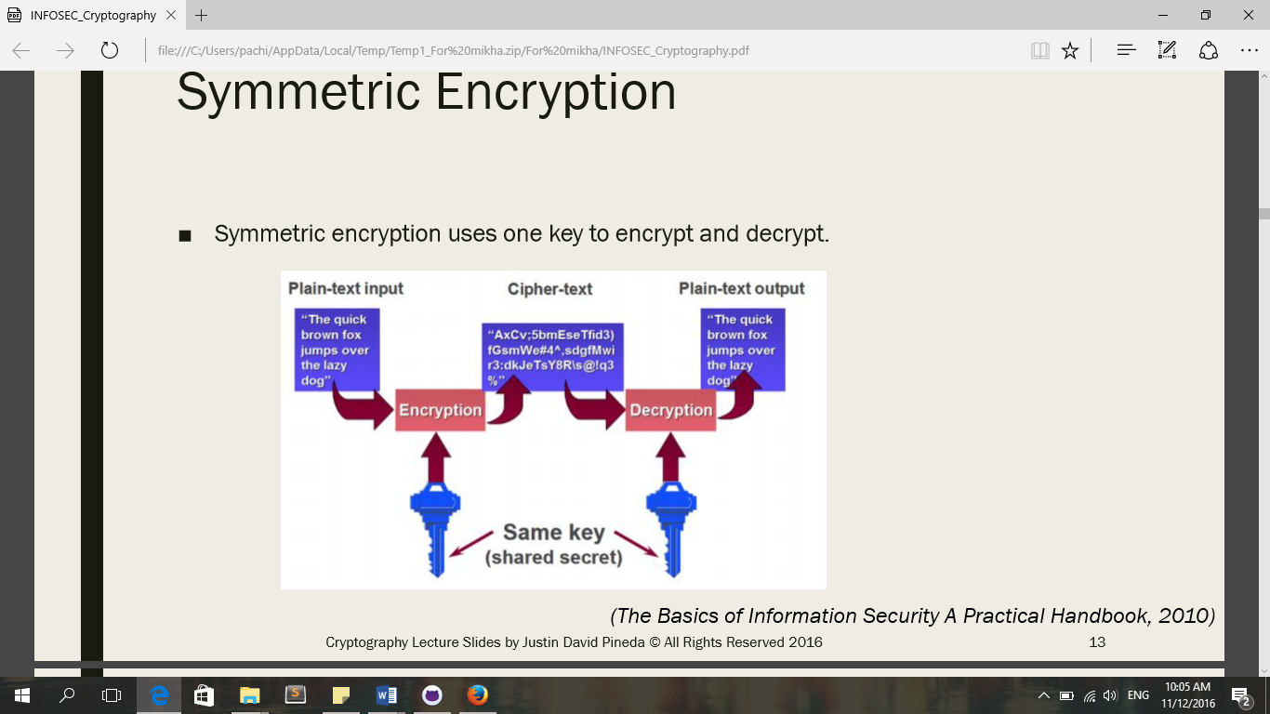In the Symmetric Key encryption algorithm, only one key is used to encrypt and decrypt data. They key can be calculated from either both decryption key or encryption key. The advantage of implementing the said algorithms is that it is relatively inexpensive but still has the capability of producing a strong key for the ciphers. However, the key must be kept secret by only the two parties involved and if anyone else discovers the secret key, then it can affect confidentiality and authentication. With an unauthorized person holding the secret key, it is possible that not only can they decrypt messages but also send encrypted messages on behalf of the authorized party affecting the legitimacy of the file. (Retrieved on December 5, 2016/http://www.ibm.com/support/knowledgecenter/SSB23S_1.1.0.13/gtps7/s7symm.html).

*Figure 2. Symmetric Encryption Process*

Diffie-Hellman Algorithm

One of the most known symmetric algorithms and is the commonly used protocol is the Diffie-Hellman. In this encryption protocol, two people who have not contacted each other before can communicate by sharing a secret key to use for encryption. This protocol is a one-way function which means that it is easy to encrypt but difficult to decrypt because to match the same key there is a mathematical formula that must be followed. Moreover, Diffie-Hellman is known to be used for avoiding attackers from interrupting the transportation of information between two persons. In implementing Diffie-Hellman, two end-users must mutually agree on positive whole numbers of two variables, such that one variable is a large prime number and the other variable is the generator of that prime number. Both end-users must choose a secret number then the user will compute for the public number. After computing for the public numbers, exchange of public numbers will take place. To finish, the computation of traded public numbers will result to their shared key without worrying about other users obtaining this information. In conclusion, Diffie-Hellman is an effective protocol because of the way it protects a temporary key for communication session. (Retrieved on September 1, 2016/ http://searchsecurity.techtarget.com/definition/Diffie-Hellman-key-exchange).

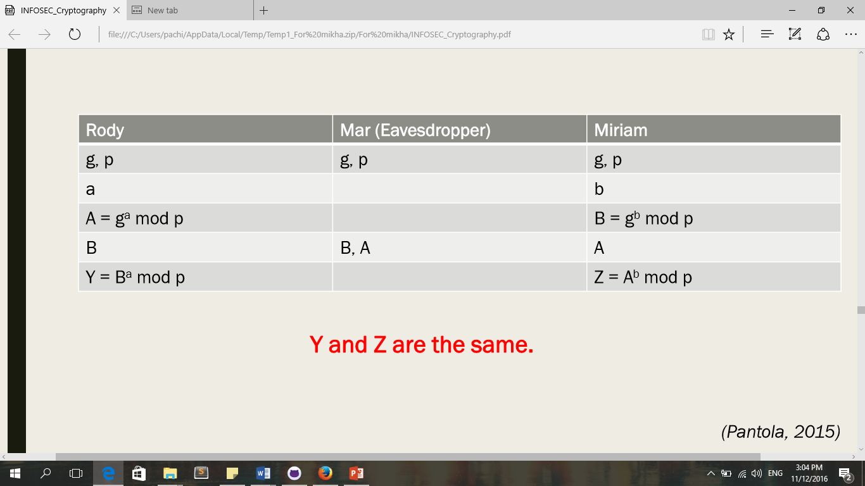

*Figure 3. Diffie-Hellman Algorithm*

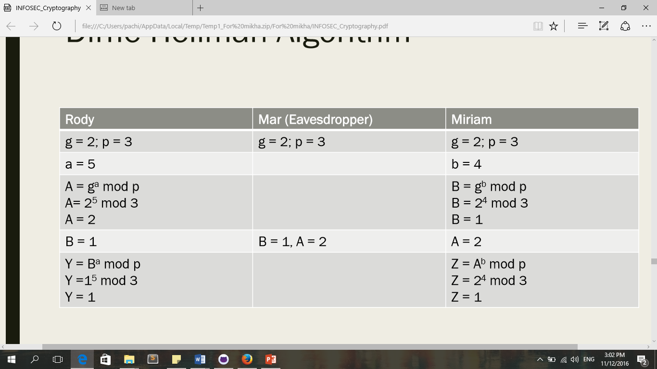

*Figure 4. Diffie-Hellman Algorithm Example*

Asymmetric Encryption

In Asymmetric algorithm, two keys are used which is known as the public and private keys. One key is provided to cipher the data and the other key is provided to decipher the data. The key that is used to cipher data is publicly known but the other key that is used to decipher is a secret which means that the receiver holds the secret key and using this secret key the receiver can crack the encrypted texts sent by the others. So, a protected information cannot be accessed as long as there is no key. To ensure the authentication, these keys must be verified and current. This algorithm uses hard math problems for the keys mainly by factoring two large numbers since computers are capable of multiplying large numbers but cannot easily factor the product therefore, it will take time to break the key. Furthermore, its main concerns are the confidentiality, integrity, authentication and non-repudiation of information. The advantage of using this algorithm is that if one of the keys has been compromised then the other one is not affected and the guessing of the key algorithm is monitored. With this, it will be easier to distinguish an intruder. (Retrieved on August 31, 2016/https://cseweb.ucsd.edu/~mihir/cse207/w-asym.pdf).

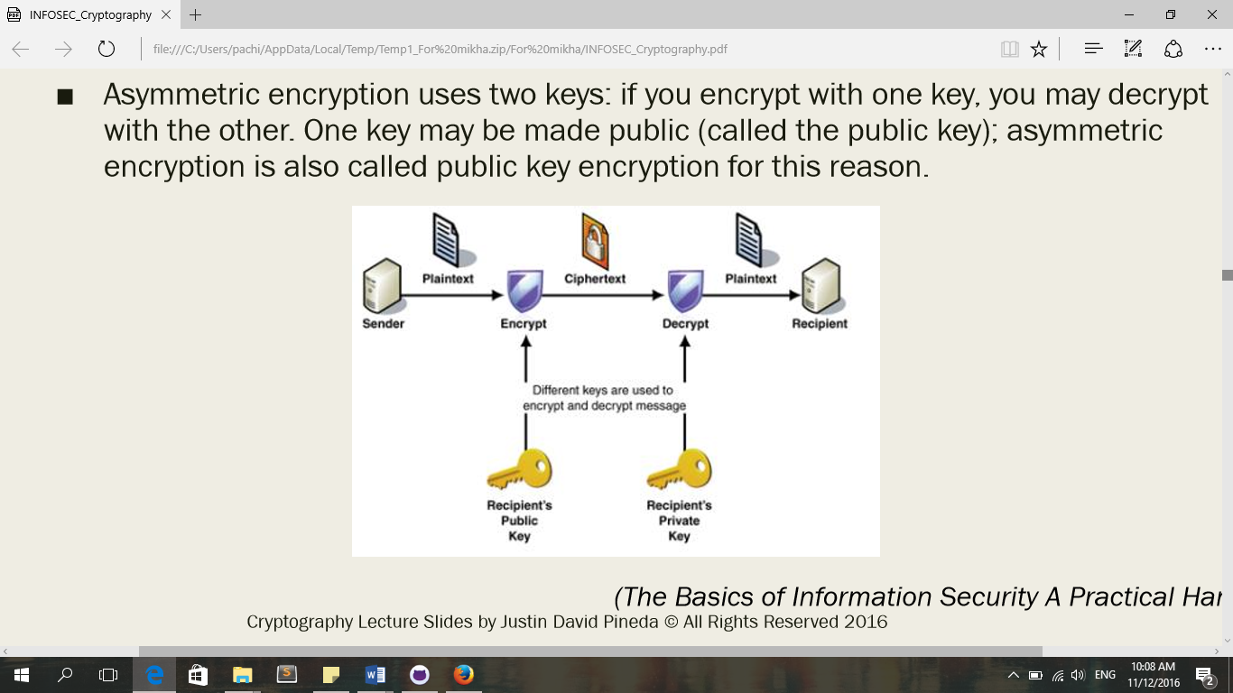

*Figure 5. Asymmetric Encryption Process*

PKI

A Public Key Infrastructure is a combination of software and procedures providing a means for managing keys and certificates and using them efficiently. Key and certificate management is the set of operations required to create and maintain keys and certificates. One of the major points being addressed in a managed PKI is the creation of keys and certificates. A PKI must offer software support for key pair generation as well as certificate requests. Furthermore, there must be procedures to verify the identity of the user before allowing him to request a certificate. Next major point is private-key protection. These private keys are either used for decryption or digital signature so it must have some reasonable level of protection. In this case, a strong password mechanism must be implemented to have an effective PKI. Now, if the user’s private-key has been compromised, the PKI must provide a means by which a certificate can be revoked. Backup and recovery, key and certificate update, and key history management are included in the major points to be addressed if a well-managed PKI is to be implemented. (Retrieved on August 27, 2016 / http://www.cgi.com/files/white-papers/cgi_whpr_35_pki_e.pdf).

Hashing

A hash is a string or number generated from a string of text that has a fixed number of length and will only vary depending on the differences in the input. The hashing algorithms are developed in a way that it is impossible to turn a hash value into its original string. Hashing is great for usage in any instance where you want to compare a value with a stored value, but cannot store its plain representation for security reasons. For instance, when a person stores a password, the input made by the user would be hash. If the user attempts to login again, the password entered by the user will again be hashed and is compared to the stored hash of the password. Once it matches, then it is certain that the user entering the password entered the right one. (Retrieved on December 10, 2016 /http://www.securityinnovationeurope.com/blog/whats-the-difference-between-hashing-and-encrypting).

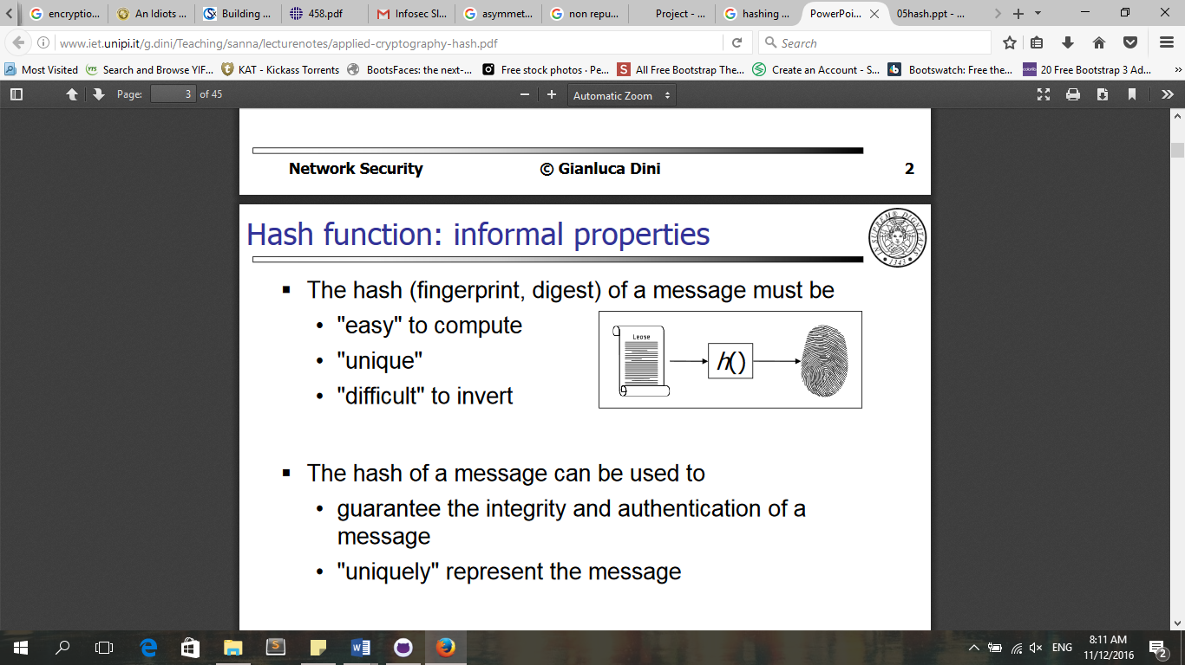

*Figure 3. Hash Function’s role*

Hashing Algorithms

Hash codes can also be called hash values, hash sums or simply hashes. Hash codes are produced by having a computer ingest any size of data and generating out a small set of hexadecimal numbers. For example, a hash code of “The Future of the Philippines” is 3c57-0b7c-a2d5-fc89-3cde-71d0-cd16-7412. Hash codes can be useful in the society that we have today. For instance, police officers use it as a forensic tool to capture criminals. It can also be used by photographers and songwriters to protect their works for plagiarizers. Additionally, IT professional use hashes to secure and protect their files and verify the data that they’ve been receiving.

An example of hash code algorithm is the MD5. In MD5, the probability of having an identical hash code is 1 in 340,282,366,920,938,463,463,374,607,431,768,211,456. Mathematicians believe that the algorithm of MD5 is weak because they have theoretically demonstrated that they can produce collisions wherein the same hash codes are produced for two different files or data. As a result, people have been switching to SHA-256 that produce hashes that unique for every 115, 792, 089, 237, 316, 195, 423, 570, 985, 008, 687, 907, 853, 269, 984, 665, 640, 564, 039, 457, 584, 007, 913, 129, 639, 936 instances.

The advantage of using a hash code is that it is an excellent detector for tampering and fraud. Although, the change of hash code is not a strong proof that there indeed is a crime committed, instead, it can only be a trigger in investigating.

Furthermore, hash codes cannot be decrypted because they are strictly one way operations. The only way to hack a hash code is to try a large possible number of inputs and hope for a match. An example was made by Drexx Laggui, principal consultant of Laggui & Associates Inc. that conducts vulnerability assessment, Internet penetration testing and computer forensics. He said that if you want to crack a system password stored as an MD5 hash code, you will need to produce an MD5 hash of every possible password you think you know and then compare each of those hash codes you have against the stored password hash code. If you find a match, then you can be certain that your guessed password is the correct password. (Retrieved on September 1, 2016/ http://opinion.inquirer.net/94849/hashcode-5-things-you-need-to-know).

PROPOSED SOLUTION TO THE PROBLEM

The current system only provides a hash value that would secure the integrity of the data. However, it lacks the security mechanism that would address the validation of both the servers and VCMs which makes it possible for other servers aside from the official servers to exist in the transmission of the election returns.

As for the proposed solution to this issue, a public key infrastructure has to be implemented to not only authenticate the data being transmitted but to also allow the verification of the servers’ authenticity. The process will start once the voting period ends at 5:00pm of the election day. In the proposed system, a server key will collect all the public keys of the voting counting machine (VCM). Assuming that the BEI have already digitally signed the election returns (ERs), the VCM will then send the ERs to the official servers. After doing so, the server key will validate the authenticity of the VCM through the Diffie-Hellman algorithm. With the said algorithm, the VCM and server key will generate a new key that uses their own public and private keys to verify that the client and server are transmitting data to an authenticated client/server. Once there is a generated key and the key players are verified, it is the only time when the VCM will encrypt file (ERs) using its private key. After that, VCM will get the hash value of the file using the MD5, SHA, and Bcrypt hashing algorithms. Then the VCM will once again encrypt the file using the Diffie-Hellman generated key, as well as its hash values. Only then the VCM will send the encrypted file and hash values to the server key. The server key will decrypt the encrypted file and hash function using the Diffie-Hellman generated key and the public key of the VCM. Server key will then get the hash value of the file to check if the hash values are the same key.

The goal of the entire process is to send and receive data to authenticated sources only and verify that the data being received was not tampered. With the said proposed system, it will eliminate the possibility of unofficial servers because for transmission of the election returns to occur, public and private key should be known to generate a key using the Diffie-Hellman algorithm. Furthermore, layers of hash functions will verify whether the data received was tampered with by a third party.

RESULTS AND DISCUSSIONS

The hybrid cryptography being proposed by this study has the capability to address the security problems that are present in the server-level of the automated election system. With the combination of both cryptography protocols and the added feature of the hashing algorithm, different layers of security have been added in order to secure the transfer of data from one entity to the other. Moreover, the proposed system ensures that the data retains its integrity and confidentiality by reducing the chances of electoral fraud. It also has the functionality of allowing only the authentic servers and VCMs to communicate and exchange data.

By incorporating the Diffie-Hellman algorithm, it lets the two authentic entities, the VCM and server key, to communicate with each other. In this process, they generate a secret key that only the two of them know. This algorithm was designed to intentionally let an eavesdropper, someone who listens while the two entities try to generate a key, hears the conversation. However, the eavesdropper would only know a portion of the communication and is unlikely to determine the shared key that the two entities generated. Nevertheless, it is unavoidable that an outside entity would try to intercept and possibly alter the communication between two entities who believe they are directly communicating with each other which is known as the “man-in-the-middle attack”. With the proposed system, even if there is someone who would launch this attack, it is still impossible for them to get the transmitted data because of the presence of the public key infrastructure. The hybrid cryptography system allows the VCM to cipher the data with its private key and the shared key produced in the Diffie-Hellman. In order for it to be deciphered, one must possess a public key and the shared key. An additional feature of the proposed system is its hash function and it is a method in identifying whether a file has been tampered. At the start of the process, before transmitting the election returns to the servers, the files are hashed using the hashing function. Three hashing functions are present in the system to avoid the possibility of collisions. Once received by the server, it will hash the file again and those values should match the values of the hash before it was sent.

The researchers of this study started to implement the security algorithm. They studied the proper application of the functions present in the current study.

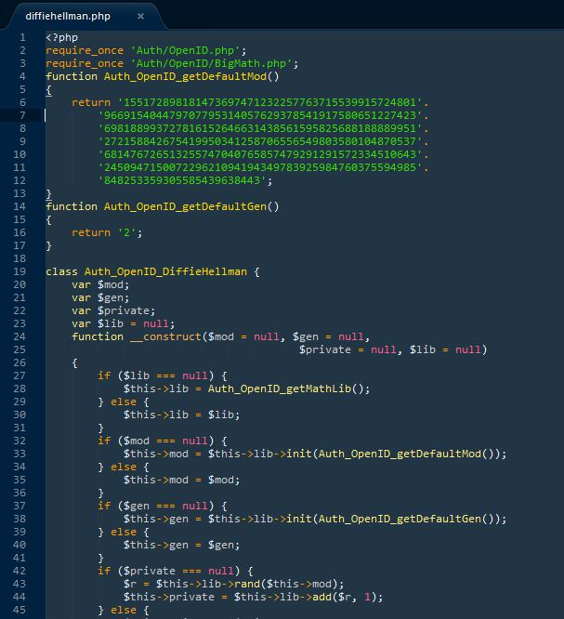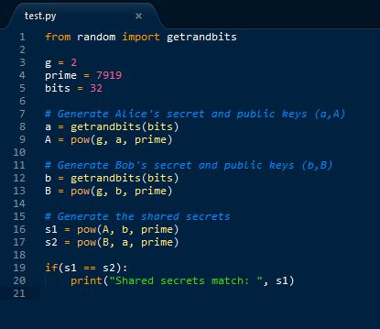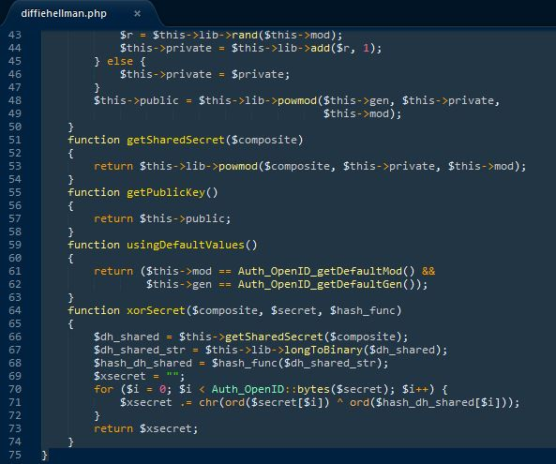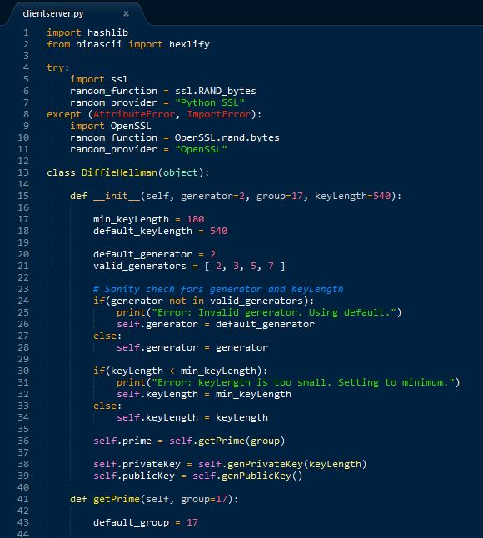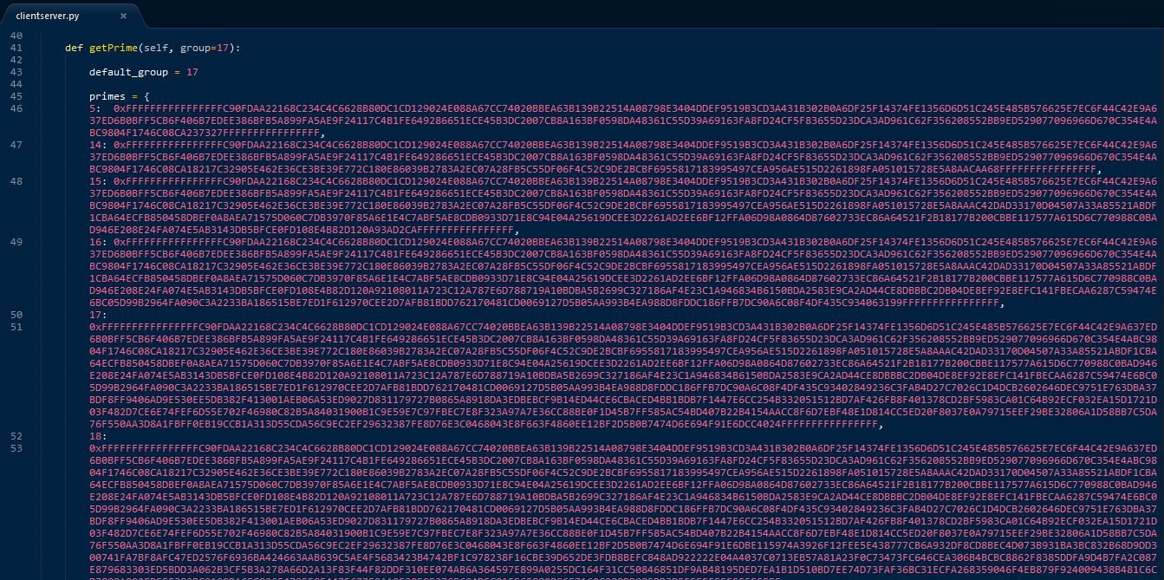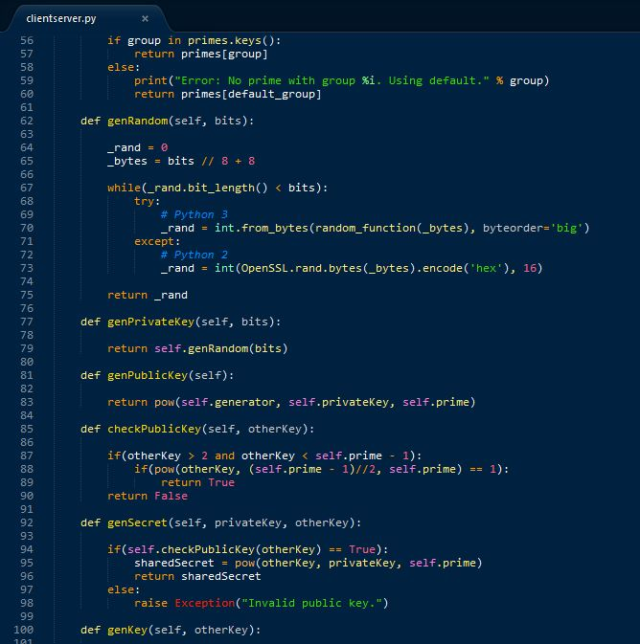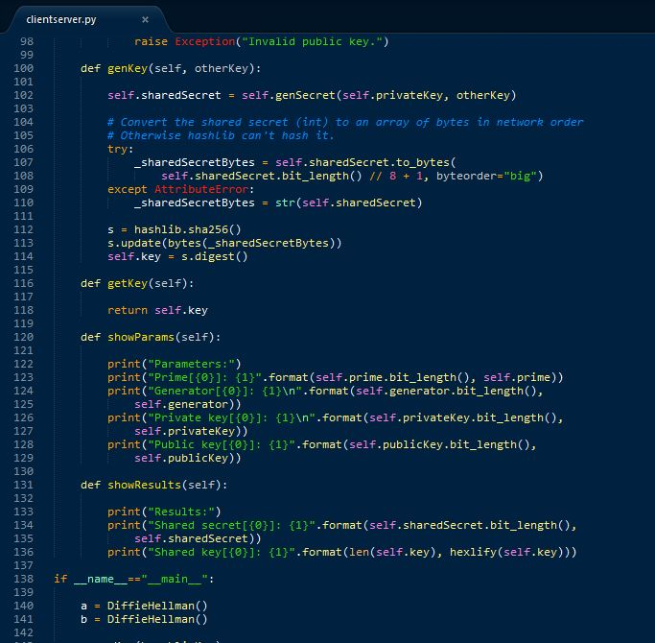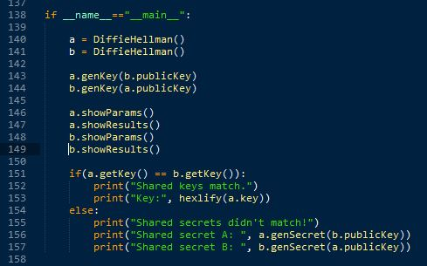

CONCLUSIONS AND RECOMMENDATIONS

The proposed hybrid cryptography system for the automated election has resolved the issues present in the current system. The researchers considered the possible attacks that may occur in the transmission of votes in the server-level. Also, various security measures were applied in order to address the system’s vulnerabilities as well as reduce the chances of electoral fraud. It prevents hackers or unauthorized individuals in tampering the election returns that may damage the integrity of the data. Moreover, the system being proposed is versatile as the concept can be applied to different areas wherein data security is needed. No matter how big or small the system is, as long as there is proper implementation, the hybrid cryptography is functional.

For the future researchers who would want to pursue this line of work, more security functionalities can be added in order to strengthen the layers of security already present in the proposed system. Lastly, a working prototype can be developed so that there can already be a preliminary model to showcase the integrate system.

APPENDICES

Event Table

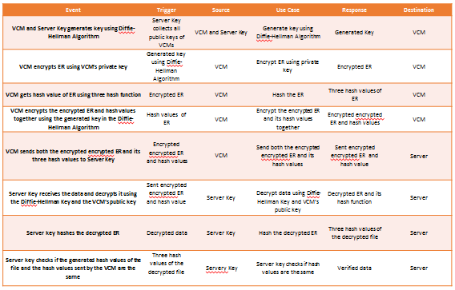

Entity Relationship Diagram

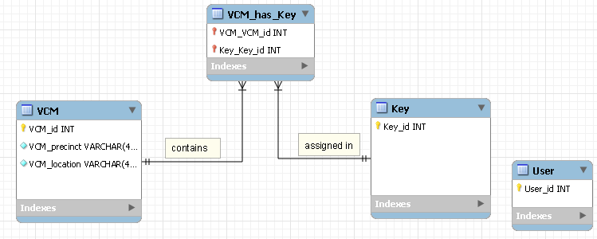

Context Diagram



Data Flow Diagram

Diagram 0

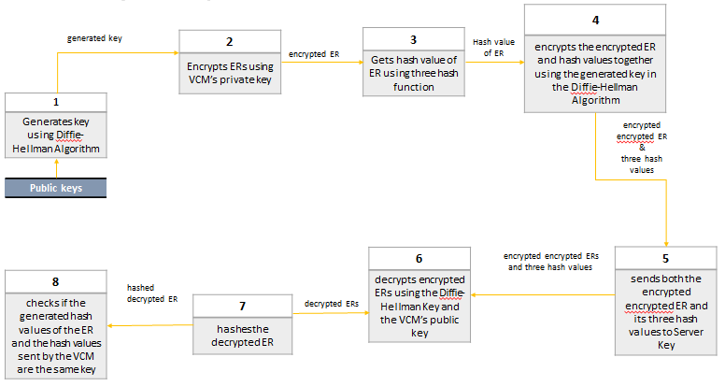

Diagram 1

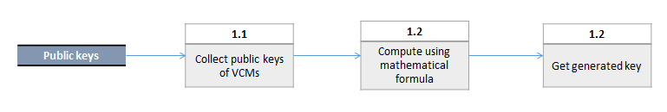

Use Case

Diagram 1

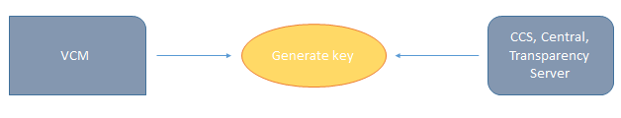

Diagram 2

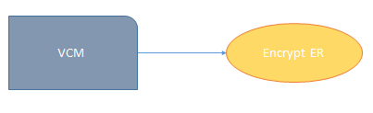

Diagram 3



Diagram 4

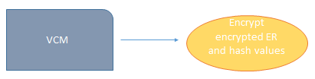

Diagram 5

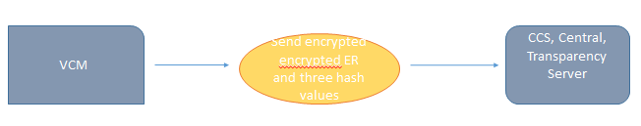

Diagram 6

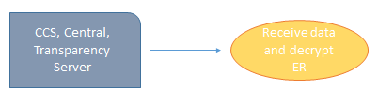

Diagram 7

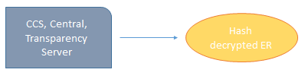

Diagram 8

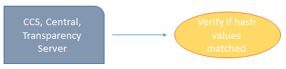

Use Case with Full Description

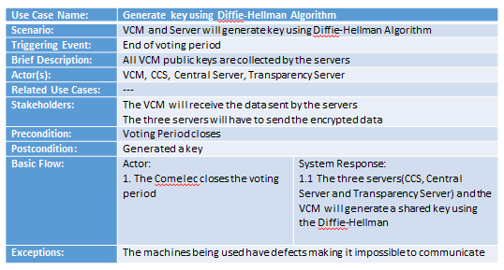

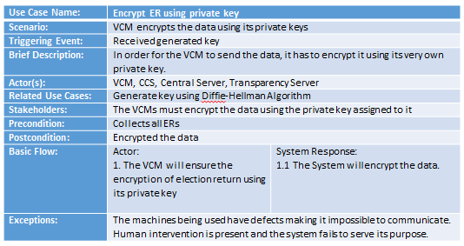

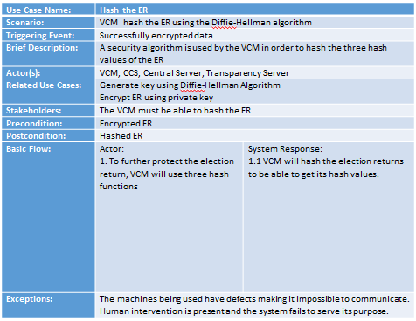

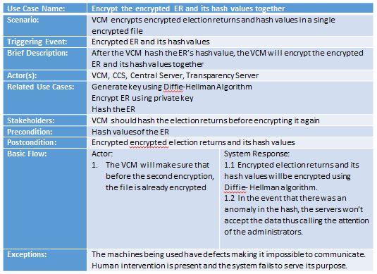

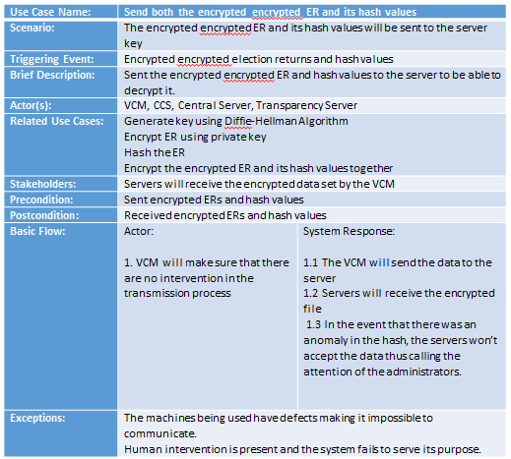

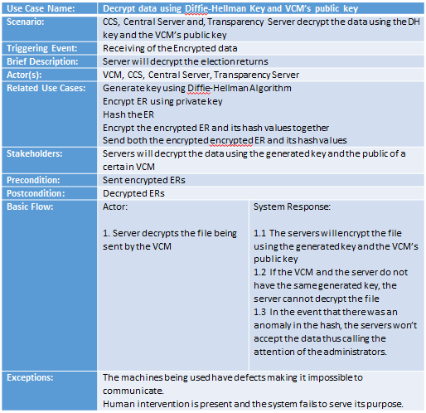

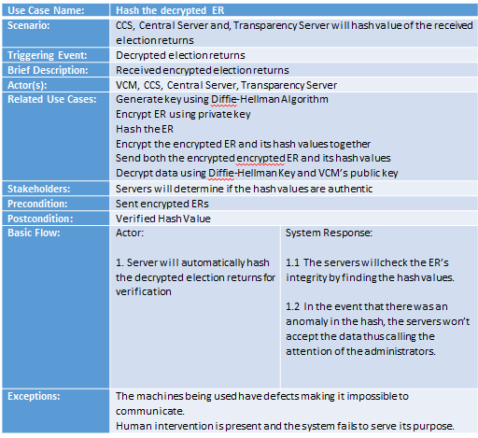

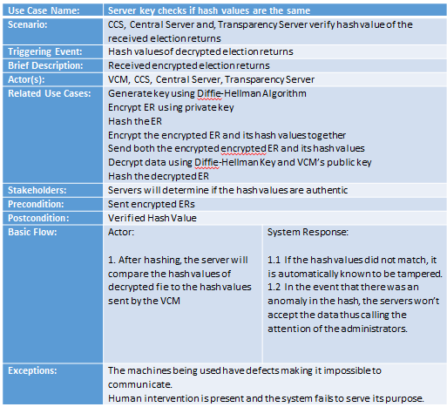

Activity Diagram

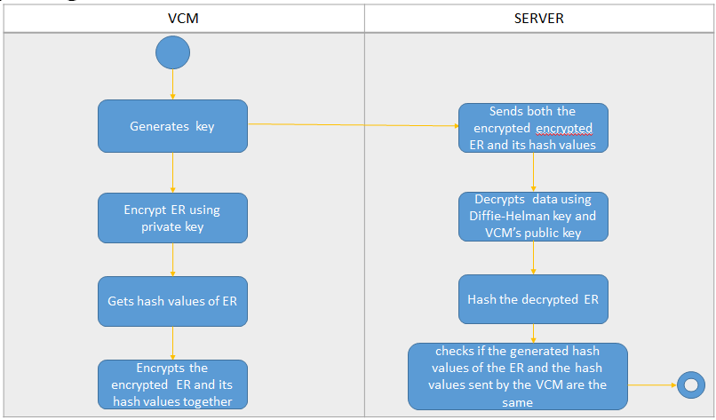

Object Diagram

Class Diagram

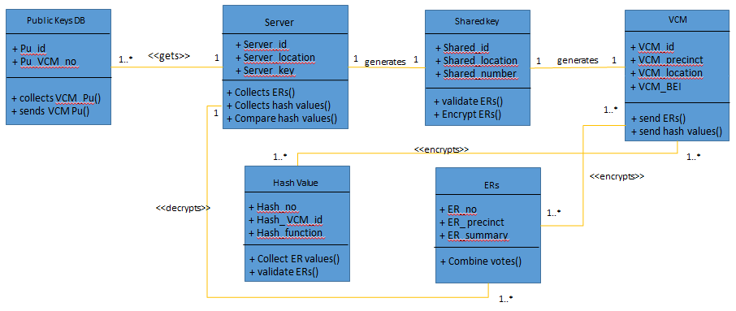

Communication Diagram

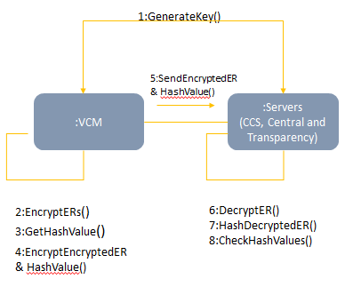

State Diagram

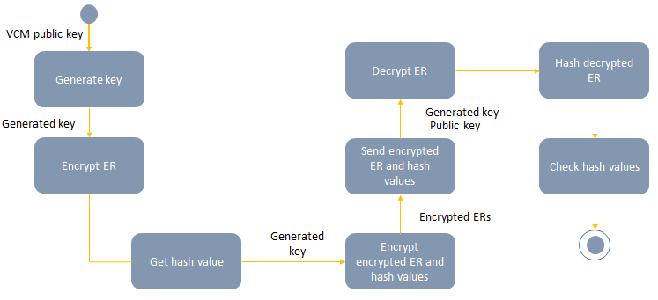

Timing Diagram

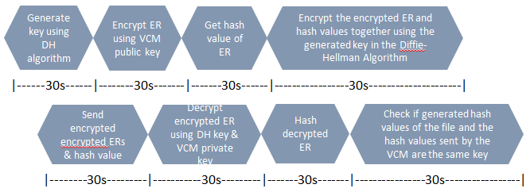

Sequence Diagram

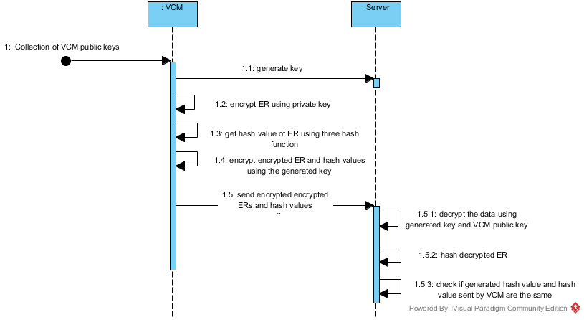

Component Diagram

Composite Diagram

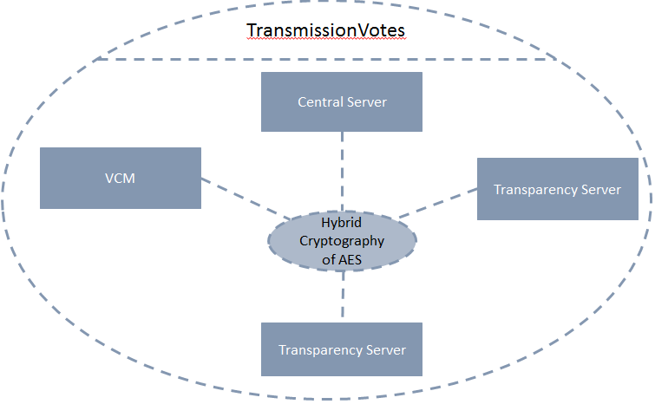

Interaction Overview Diagram

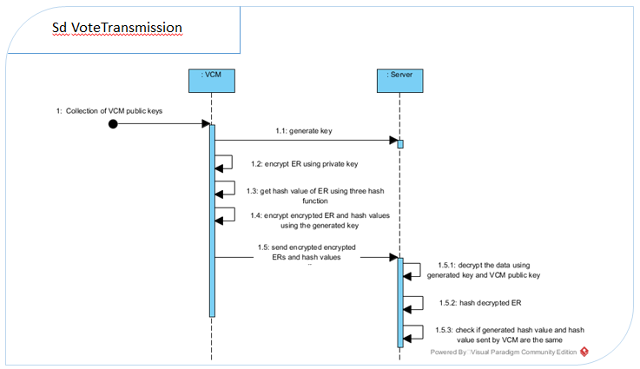

Package Diagram

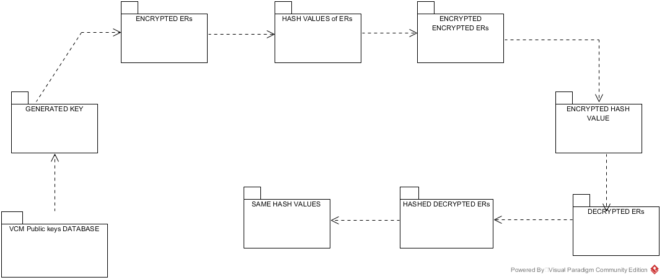

Deployment Diagram

